BAPTIST CHURCH

pe02110_September Nursery Schedule

2 0-2 Year Olds Evelyn Robinson

3-4 Year Olds Paula Knobloch

9 0-2 Year Olds Kristi Suchomel

3-4 Year Olds Terri Edwards

16 0-2 Year Olds Tami Knipstein

3-4 Year Olds Paula Hicks

23 0-2 Year Olds Angie Fisher

3-4 Year Olds Karen Cotton

Helper Mickey Stanford

23 0-2 Year Olds Teresa Schane

3-4 Year Olds Jana Moore

**Weekly Service & Activity Schedule:**

SUNDAY

Sunday School 9:45 a.m.

Morning Worship Services 11:00 a.m.

Youth Activities 5:30 p.m.

Evening Services 6:00 p.m.

MONDAY

“Work-It-On-Out” 6:30 p.m.

WEDNESDAY

“Work-It-On-Out” 6:00 p.m.

Youth Worship 6:30 p.m.

Wednesday Services 7:00 p.m.

THURSDAY

“Work-It-On-Out” 6:30 p.m.

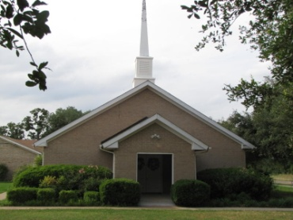

1662 CR 305

McDade, TX 78650

Phone: (512) 273-2743

Email: [KnobbsSpringsBaptist@gmail.com](mailto:KnobbsSpringsBaptist@gmail.com)



*KnobbsSpringsBC.com*

Interim Pastor

Brother Dwight Reagan

Home: 512-247-6448 / Cell: 512-964-1433

Email: dwlReagan@aol.com

**Other Contacts**

*Cleyon Davis – Treasurer*

(512) 856-2524

*Kimberly Tabor – Office Manager*

(512) 698-2804

**September Ushers**

Jarvis Stewart, Geary McManus

Joe Wilson, Wesley McManus

**September Hostesses**

Sheila Waggoner, OtisannMcManus

Darlene Gravell, Terri Edwards

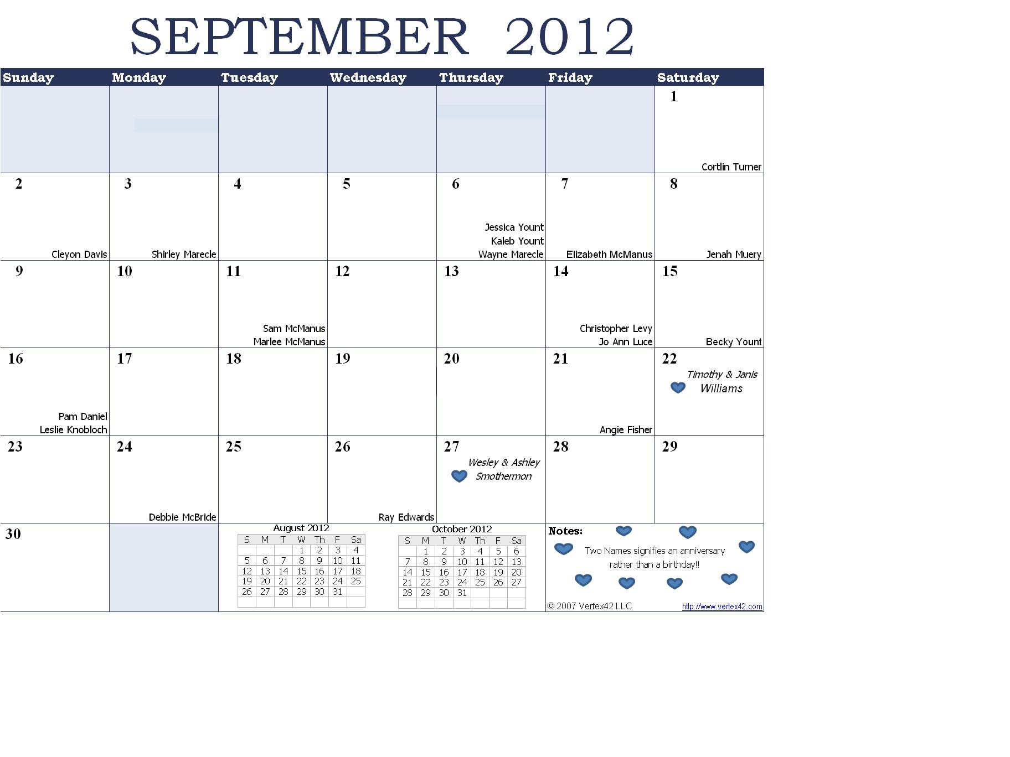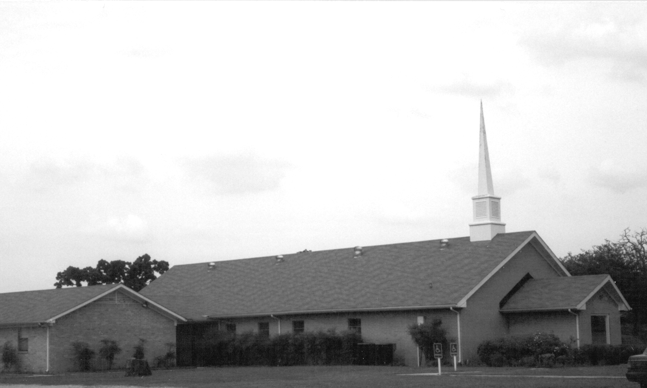

Please email KnobbsSpringsBaptist@gmail.com to be removed from our mailing list. Thanks!

September Newsletter

Knobbs Springs Baptist Church

1662 CR 305

McDade, TX 78650

Non-Profit Organization

U. S. Postage Paid

Permit # 1

McDade, Texas